|  |  |  |  |
| --- | --- | --- | --- |
| Confidence interval | α | α/2 | Z **α/2** |
| 90% | 0.10 | 0.05 | 1.645 |
| 95% | 0.05 | 0.025 | 1.96 |
| 99% | 0.01 | 0.005 | 2.576 |

Question: A sample of 100 tyres taken from a lot. The mean life of tyres is found to be 39,350 kms with a standard deviation of 3,260. Could the sample come from a population with mean life of 40,000 kms? Establish 99% confidence limits (interval) within which the mean life of tyres is expected to lie

Solution; there is no significant difference between the sample mean and hypothetical mean

 = = =326

Z= = =1.994 



= 39350 + 2.58(326)

= 38508.92 – to – 40191.08

Here the mean life of tyre expected to lie between 38509 to 40191

Question: calculate standard error of mean from the following data showing the amount paid by 100 firms in Calcutta on the occasion of Durga pooja.

Mid value 39 49 59 69 79 89 99

No. of firms 2 3 11 20 32 25 7

Solution:  =

Calcualtion of standard deviation

|  |  |  |  |  |
| --- | --- | --- | --- | --- |
| Mid value m | f | d = (m-69) | fd | fd2 |
| 39 | 2 | -30 | -60 | 1800 |
| 49 | 3 | -20 | -60 | 1200 |
| 59 | 11 | -10 | -110 | 1100 |
| 69 | 20 | 0 | 0 | 0 |
| 79 | 32 | 10 | 320 | 3200 |
| 89 | 25 | 20 | 500 | 10000 |
| 99 | 7 | 30 | 210 | 6300 |
|  | N=100 |  | ∑fd=800 | ∑fd2=23600 |

Use formula for Standard deviation is frequency is given

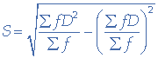

= 13.11

= =1.311

Two tailed test for difference between the two samples

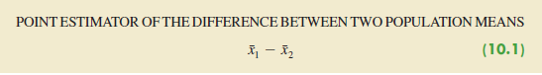



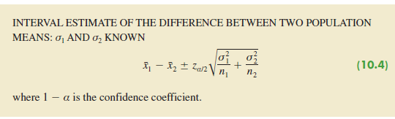

**Question**: Based on data from previous customer demographic studies, the two population standard deviations are known with *σ*1 = 9 years and *σ*2 = 10 years. The data collected from the two independent simple random samples of Greystone customers provided the following results.

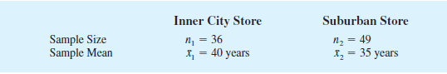

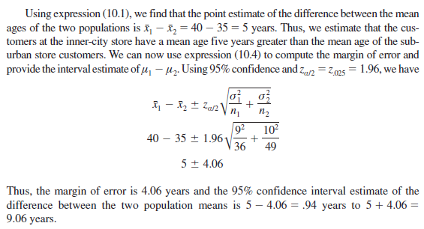

**Question**: A man buys 50 electric bulbs of ‘Philips’ & 50 electric bulbs by ‘HMT’. He finds that ‘Philips’ bulb give an average life of 1500 hours with a standard deviation of 60 hours & ‘HMT’ bulb give an average life of 1512 hours with a standard deviation of 80 hours. Is there a significant difference in the mean life of the two makes of bulbs?

Solution: calculating standard error of difference of means, use this formula

Here σ1 = 60 n1 = 50 & σ2=80 n2=50



After calculation

Standard error of means is = 14.14

Point estimate of difference between the two mean = 1512-1500 = 12

Z =( 1 – x2)/S.E. = 12/14.14 = 0.849

Question: A simple sample of the height of 6,400 English men has a mean of 67.85 inches and a standard deviation of 2.56 inches where a simple sample of heights of 1,600 Austrians has a mean of 68.55 inches and standard deviation of 2.52 inches. Do the data indicate that the Austrians are in the average taller than the English men? Give reason for your answer

Solution: Let us make the hupothesis that there is no significant difference in the mean height of Englishmen and Austrians

Standard error of means is

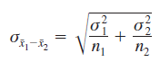

S.E=

= 0.0707(**AFTER CALCULATION**)

Point estimate of difference between the two mean = 68.55-67.85 = 0.7

Z = X1 – X2

S.E

=

Question: The life time of electric bulbs for a random sample of 10 from a large consignment gave the following data

Item 1 2 3 4 5 6 7 8 9 10

Life in ‘000 hours 4.2 4.6 3.9 4.1 5.2 3.8 3.9 4.3 4.4 5.6

Can we accept the hypothesis that the average life time of bulbs is 4000 hours

Solution: Let us take the hypothesis that there is no significant difference in the sample mean and the hypothetical population mean. Appying the t-test



Where t = X - μ

S**/**

Calculation of mean & S

|  |  |  |
| --- | --- | --- |
| X | (X-X ) | (x-x)2 |
| 4.2 | -0.2 | 0.04 |
| 4.6 | 0.2 | 0.04 |
| 3.9 | -0.5 | 0.25 |
| 4.1 | -0.3 | 0.09 |
| 5.2 | 0.8 | 0.64 |
| 3.8 | -0.6 | 0.36 |
| 3.9 | -.5 | 0.25 |
| 4.3 | -0.1 | 0.01 |
| 4.4 | 0 | 0 |
| 5.6 | 1.2 | 1.44 |
| ∑x=44 |  | ∑(x-x)2=3.12 |

Calculate standard deviation: √ ∑(x-x) 2/ n-1 = 0.589

Put value in‘t’ formula = 2.148(After calculation)

Question: Two types of drugs were used on 5 and 7 patients for reducing their weghts. Drug A was imported and drug B was indigenous. The decrease in the weight after using the drug for six months was as follows:

Drug A 10 12 13 11 14

Drug B 8 9 12 14 15 10 9

Is there a significant difference in the efficacy of the two drugs? If not , which drug should you buy?( for degree of freedom or v or d.o.f=10, t0.05 = 2.223)

Solution: let us take the hypothesis that there is no significant difference in the efficacy the two drugs. Applying t-test

t = X1 – X2

S

Here S is not given then we have to calculate S(sample standard deviation)\

S = ∑(x1-x1) 2 + ∑(x2-x2) 2

n1 + n2 -2

|  |  |  |  |  |  |
| --- | --- | --- | --- | --- | --- |
| xi | (x1-x1) | (x1-x1) | xi | (x2-x2) | (x2-x2) |
| 10 | -2 | 4 | 8 | -3 | 9 |
| 12 | 0 | 0 | 9 | -2 | 4 |
| 13 | 1 | 1 | 12 | 1 | 1 |
| 11 | -1 | 1 | 14 | 3 | 9 |
| 14 | 2 | 4 | 15 | 4 | 16 |
|  |  |  | 10 | 1 | 1 |
|  |  |  | 9 | -2 | 4 |
| ∑x=60 |  | 10 | 77 |  | 44 |

Calculate ‘S’ substitute value in formula

Where X1 =

X2 =

Calculate “t” substitute value in formula

t = 12 – 11

2.324

=0.735(After calculation)

Calculate degree of freedom = n1 + n2 – 2 = 5+7-2 = 10

Compare tabular value and calculated value

Calculated value of ‘t’is less than table value, the hypothesis is do not reject